**E-GOVERNANCE**

**CAPSTONE PROJECT**

**PROF . T.IWAGOSHI**

**ACKNOWLEDGEMENT:**

We might want to express our earnest appreciation to our educator Dr.T.Iwagoshi and our institution for giving the awesome chance to do this venture, through which we can improve our exploring ability and learning.

**ABSTRACT:**

A capstone project venture is a amazing opportunity for all the students to put in their knowledge of past 3 semester and make the ideas into reality by creating a working module of any branch of science one have mastered and try to get revolution by his work in the world of science

coming to our contribution to this venture is our project which is E-Governance is web page application which is the Revolutionary way of governing both the government and people where most of the things are done Electronically i.e Online Internet governing which will basically make things much transparent and obedient . This will allow people to conduct all their government duties online which will save tons of time and work done will be of profound qual

**ABOUT THE TEAM:**

|  |  |
| --- | --- |
| |  | | --- | | we team members where always into the project with great zeal and co-operation it was glad working with each other it was great sharing idea provoking thoughts solving out answers going through the phases of technical study and getting inspired by each other applauding each others merit and learning from them was very knowledgeable. |   **Team members :** |

1)Nitesh kumar reddy (16324) – JAVA , HTML,CSS (FRONT-END DEVELOPER)

2) Adithya paspu (17940) – JAVA , SERVLET,JSP ( FRONT-END DEVELOPER)

3)Vijay kethan (16490 ) – Database management ( BACK-END DEVELOPER)

4)Shiva kumar ( 16279) – JAVA ,JSP ( FRONT – END DEVELOPER)

**TABLE OF CONTENT:**

**1. INTRODUCTION**

**2. FEATURES**

**2.1. CLIENT**

**2.2. ADMIN**

**3. ENVIRONMENT**

**3.1. BACK-END**

**3.2. FRONT-END**

**3.3. FRAMEWORK**

**3.4. MYSQL**

**3.5. SERVER**

**4. TOOLS**

**5. DEVELOPMENT TOOLS**

**5.1. FRONT END**

**5.2. BACK END**

**6. ARCHITECTURE**

**7. SOURCE CODE**

**8.1. SOURCE CODE FOR LOGIN CONTROLLER**

**8.2. SOURCE CODE FOR ADMIN SIDE PAGE**

**9. DATABASE**

**10. FINAL INTEGRATION**

**10.1. LOGIN PAGE**

**10.2. CLIENT PAGE VIEW**

**10.3. ADMIN PAGE VIEW**

**1. INTRODUCTION:**

*In recent times, information technology has a tremendous influence on how different Government departments operate. Governments around the world are increasingly interested in the potential for delivering government services through internet. Examples of substantial transition to electronic service delivery can be found in some sectors in some countries,*

*So we took this interest in initiating a idea of creating E-governance web-page which helps all the citizens to have all their government duties done in one window like keeping track of all the news going on and post their comments and reviews and by using our path breaking technology of online payment service all the citizens can pay their bills by looking up for them in our bill payment tab which will be syncd to the provided email service in our login and registration services too.*

*objectives :*

|  |  |
| --- | --- |
| |  | | --- | | *1.Education/job search*  *2.Citizen Responsibilities.*  *3.Health care Information.*  *4 Pettition submission*  *5.Electricity Bill Payment.*  *6.Water Bill payment…Etc* | |

**2.FEATURES:**

1. E- governance :

2 Online payment

3 Petition submission

4 Review writing

5 Bill payment management

**ELABORATION OF THE FEATURES :**

**E-GOVERNANCE :**

This project weighs name of the project but serves as a wise too by helping all the people to have a tab of all the action going on in the country i both state and national and let be everyone aware of all the information going on in the country, for an instance any job opening is available in any company then this handle helps the information to be navigated to every individual this helps people to get benefitted with the things they are really in need of . all the news like weather and things etc

**Individual online Email-id registration** :

in this web site everyone can login or can sign up with their personal e-mail id in which they can WRITE SHARE and POST different things online this also helps them keep track of all the information and to handle things from a personnel point of view

**online bill payment** :

this is one of the path breaking feature where each individual will be provided with a online payment service where he can pay his all the online bill such as PGnE BANK STATEMENTS and other bill etc. this helps every indivual to keep track of all their bill and helps them get paid on time and skip all the late fee’s.

**petition submission** -

in this feature each of customer after logging into the application with their indiviual email id they will be provided with a online petition submission feature where they can put up a online petition where they can start a petition on any of the and can be shared to all the people signed into it and take their votes and pass new amendments for the betterment of the society

**review writing :**

here each user will be provided with a tab to write a review on any of the issue going on in the management of the society and get views of different people on it and get this at a glance of the government and make them develop different issues in the surroundings .

**2.1. CLIENT:**

The client who is named as customer login and sign in where he can sign up as a new customers while entering all their details in the signup page in this project and also in the website will have a login option into the website where he can measure the features like Petition submissions where he can create online petitions on different issues in the public and in the society which will be useful as by taking the decision of the people and amending them with the approval of the government , review writing which is This is one of the profound features which helps the citizens to write a review on different issues and and works carried out by the government so that the government can know the feeling of the people and their take on a particular situation going on in the state and In the country and where as online payments This is one of the path-breaking feature of our project here we provide a feature of ONLINE PAYMENT . This helps the citizens to pay all the utility bills online with a stroke of your fingers and get relieved by the lagging of schedule .well online payment is not such a great evolution but what path breaking in this feature is that all the bill can be made in one window and get done with all the bills payment at once

**2.2. ADMIN:**

The Admin is the administrator who handles the mechanism of all the working and also take cares of the diagnosis of the web-site . the web-site also has the Admin-login where he can login and verify the post of the customers to be genuine and important to be given such attention and give space on the site as they'll be lot of things to be juxtaposed and managed and also the see the smooth running of all the bill payment sites which are present in the site and also driving the customers to the site properly the admin also manages the data loaded in the database to see they are kept safe and there won’t have any data loss

**3. ENVIRONMENT:**

**3.1. BACK-END:**

**MySql :**

Mysql was used in the project as a scripting language for the server side . MySQL is the most popular Open Source Relational SQL database management system. MySQL is one of the best RDBMS being used for developing web-based software applications.

**IMPORTANCE OF MYSQL IN OUR PROJECT:**

MySql scripting language has been used in this project for the creation of tables and addition of the data in the database it is very efficient to use Mysql because it has very intact logics for the creation of table and piling up of the data sequentially and also the management of the data and here the storage of the information of different labels like login page and the information loaded in that page are

We have used the PHP with HTML to develop our application login page.The login controller code which is called by the login page when the details are entered by the user to perform the action to be taken when the login button is liked on the login page is also written in the PHP .

**3.2. FRONT-END:**

**JAVA and JSP :**

java and jsp is the one of the most widely and fundamentally used technology which plays a crucial role in the formation of dynamic web pages with the fundamentals of HTML and XML . JSP is just as similar as PHP but the is runs and constructs the programs in the language of java and runs the javaserver pages which is compatible with the java servers like Apache Tomcat server.

**IMPORTANCE OF JAVA and JSP IN OUR PROJECT:**

In this project java and jsp has been used for the creation of the business logics in the project all the codes have been written in both java and jsp where the carrying of the services like creation of login page and sign up page where the details of the customer are entered and the validation of them is done with the data stored in the database

**HTML :**

HTML is the standard markup dialect for making Web pages. HTML remains for Hyper Text Markup Language. HTML depicts the structure of Web pages utilizing markup. HTML components are the building squares of HTML pages. HTML components are spoken to by labels.

**CSS :**

Cascading Style Sheets (CSS) is a template dialect utilized for depicting the presentation of an archive written in a markup dialect.

**IMPORTANCE OF CSS AND HTML IN THE PROJECT :-**

CSS and HTML is the markup language which is used for the creation of display of the web pages and the presentation of the pages as which label should be placed and displayed on the dynamic web page like taking example of a web page like the login page the details in the login page as the Name , password and number and rest of the details and also the images used in the pages for the display of those should be coded for the provision of space to them to be displayed on the web page and also the header and footer of the page is coded and provided by this services

**3.5. SERVER:**

Apache tomcat server :

Apache Tomcat, frequently alluded to as Tomcat Server, is an open-source Java Servlet Container created by the Apache Software Foundation. Tomcat server is basically a ready made Jsp running application.

**wamp server :**

In registering, an answer stack or programming stack is an arrangement of programming subsystems or parts expected to make an entire stage to such an extent that no extra programming is expected to bolster applications. Applications are said to "keep running on" or "keep running on top of" the subsequent stage. A few meanings of a stage cover with what is known as framework programming.

**Importance of Tomcat server and wamp server in the project :**

Tomcat server was used in this project for the running of the programs created in the java and jsp language such as login page where as customer login and administration login , registration page

for the customers who are signing up for the first time into the application and rest all the programs like online payment, petition writing

**5. DEVELOPMENT TOOL:**

**5.1. IDE FOR DEVELOPMENT :**

**Eclipse neon :** 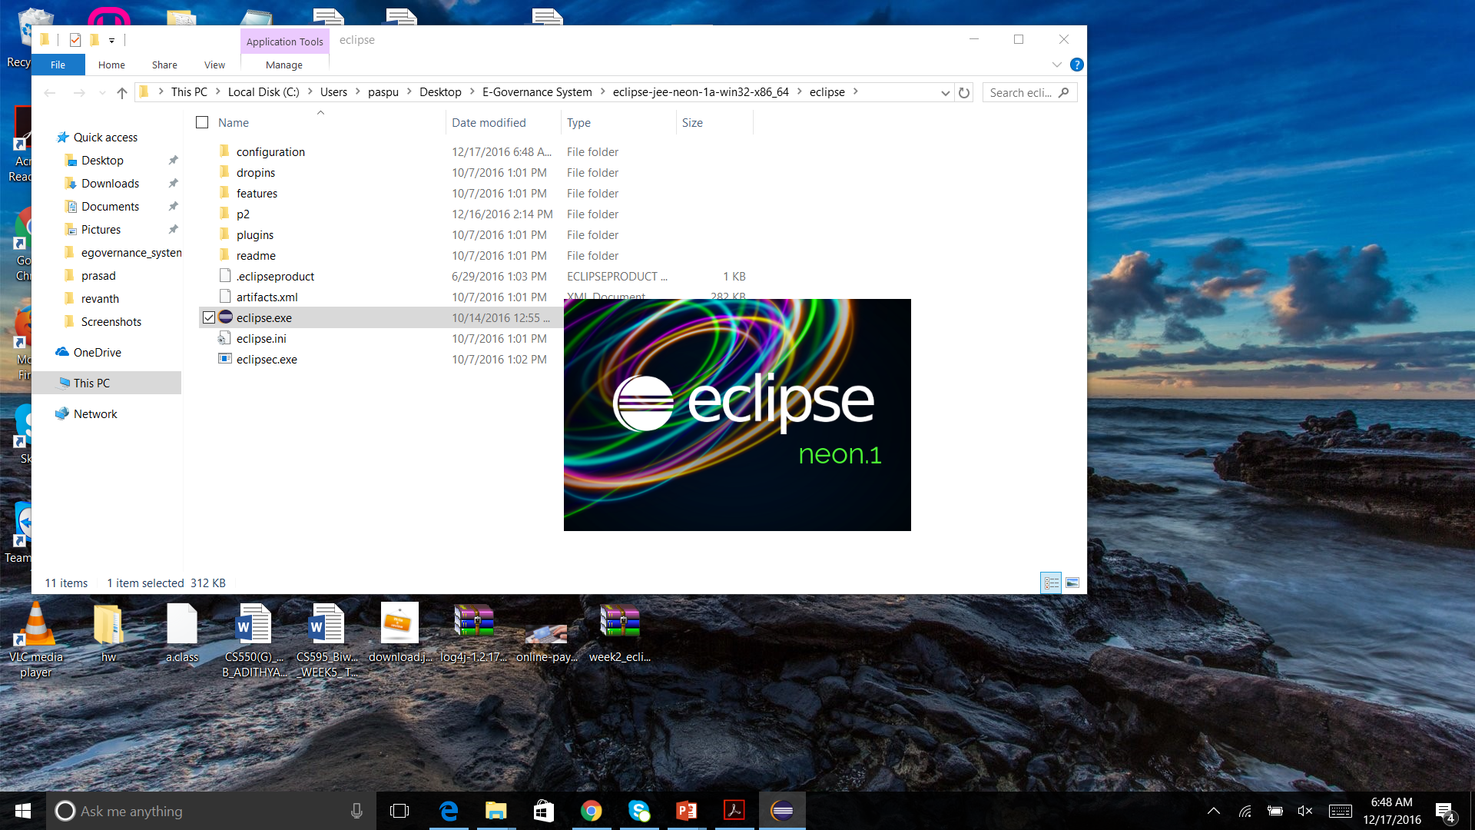

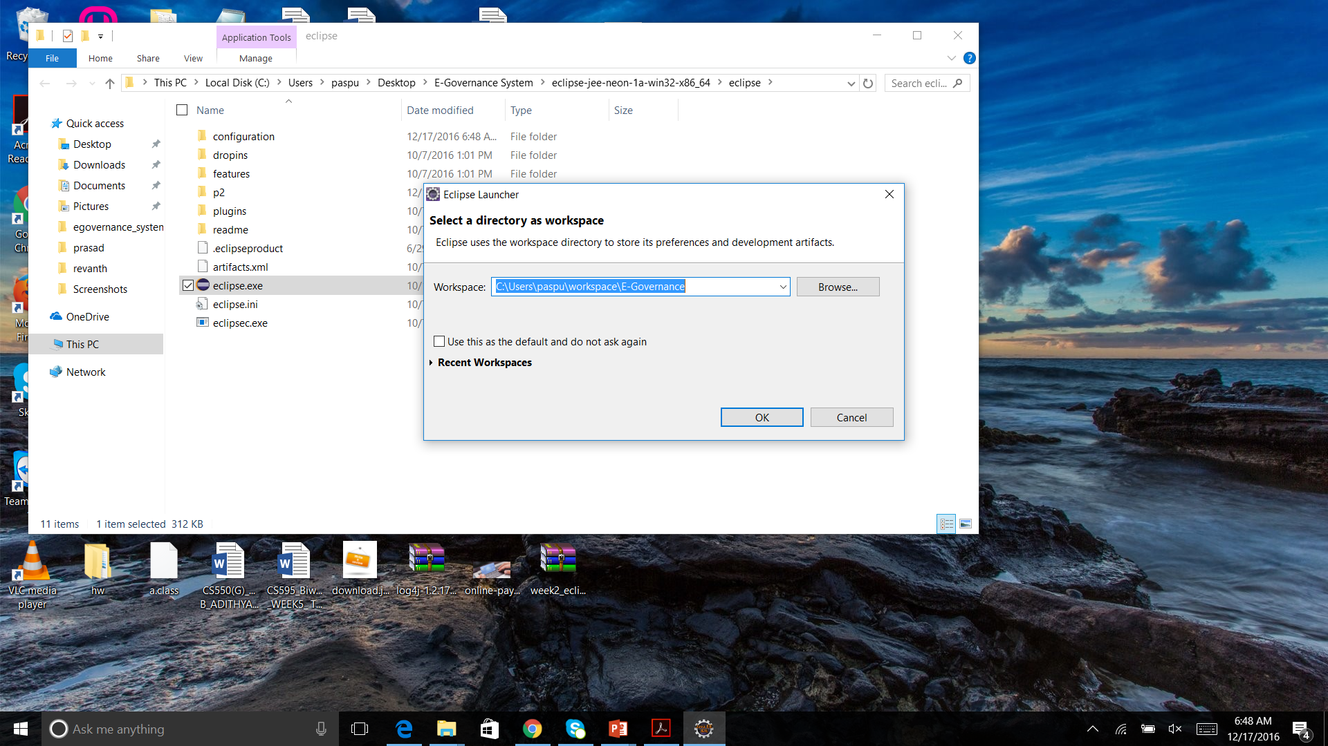

**6. ARCHITECTURE:**

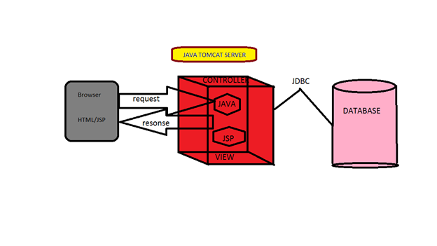

**T**he scope of this project is, Personal identity management project is implemented in visual JAVA platform. Main idea of this project is to implement a online secure storage of data which include files, username an passwords of different accounts. This application provides solution for online file sharing where data stored in this application can be view from any where and other features of this application is generally every user who works on internet creates many accounts for different sites with different usernames and passwords so remembering them is not possible. Users can store username and passwords in this application and access when ever required.

NON – FUNCTIONAL REQUIREMENTS :

**Reliability** of the system is reliable and produces accurate resulting from implementation of security measures. Security is provided using password protection, release when time out etc..

**Maintainability** of the system will be designed as a closed system. New methods can be added easily with little or no changes in the existing architecture.

**Portability** of the systemshould be portable. It can be deployed on any windows platform and used.

**Security protection** of computer based resources includes hardware, software, data, procedures and people against unauthorized use or natural disaster is known as system security.

**System Integrity** refers to the power functioning of hardware and programs, appropriate physical security and safety against extent threats such as eavesdropping and wiretapping.

**Privacy** defines the rights of the user or organizations to determine what information that they are willing to share with or accept from others and how the organization can be protected against unwelcome, unfair or excessive dissemination of information about it.

**Confidentiality** is a special status given to sensitive information in a database to minimize the possible invasion of privacy. It is an attribute of information that characterizes its need for protection.

**8.SOURCE CODE:**

**8.1Source code for login controller:**

The login controller code is called when the login details are entered in the login page. The login controller will call the login form which is used for validating the user.

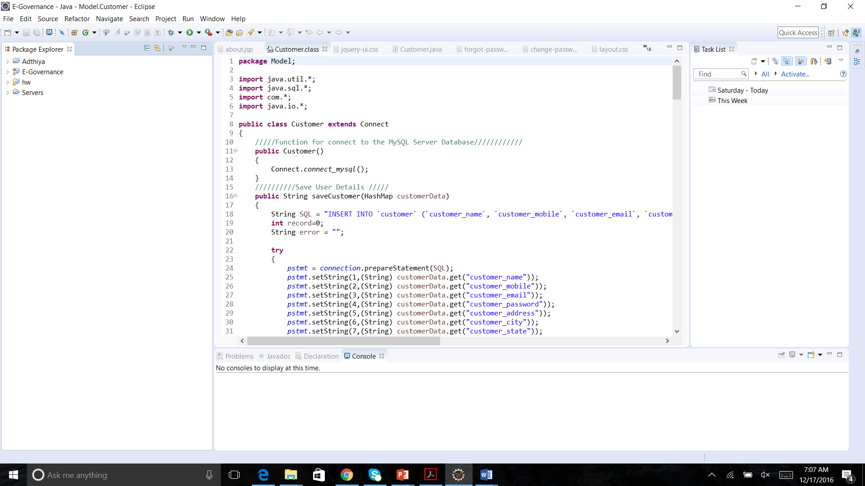

**8.2. Admin side add client source code:**

This source code is used to add the client for managing the client.

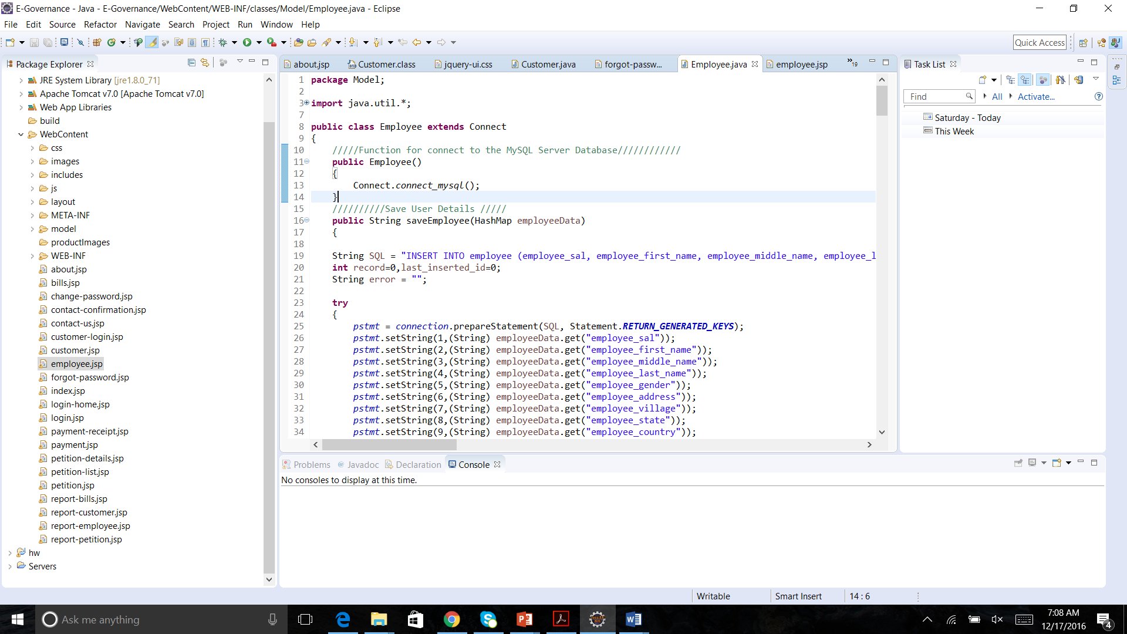

**9.DATABASE:**

**User table:**

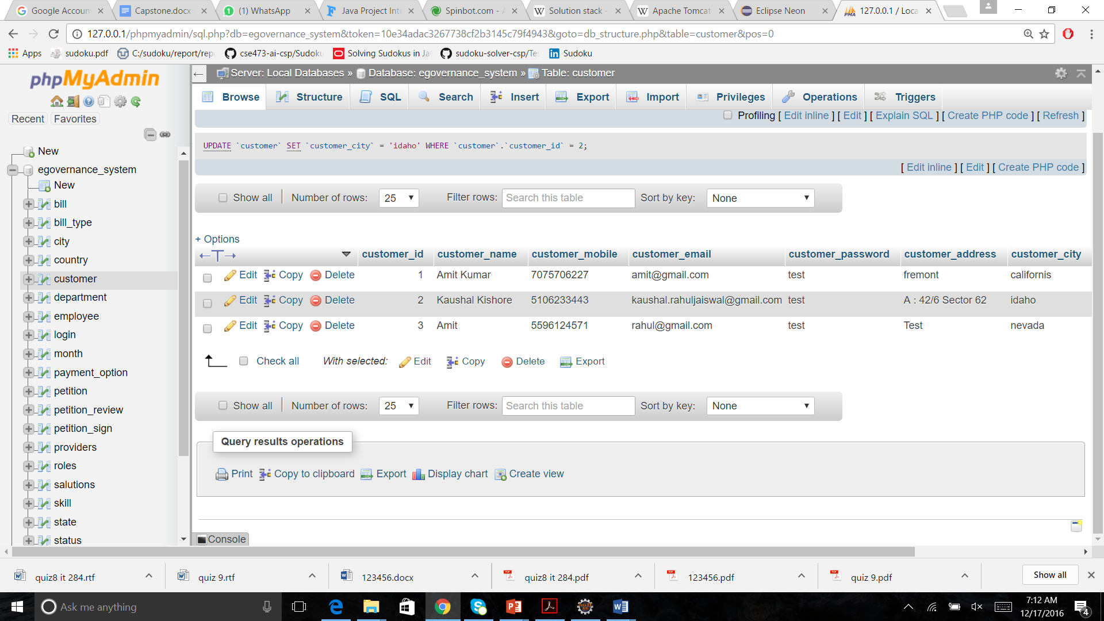

**Client table:**

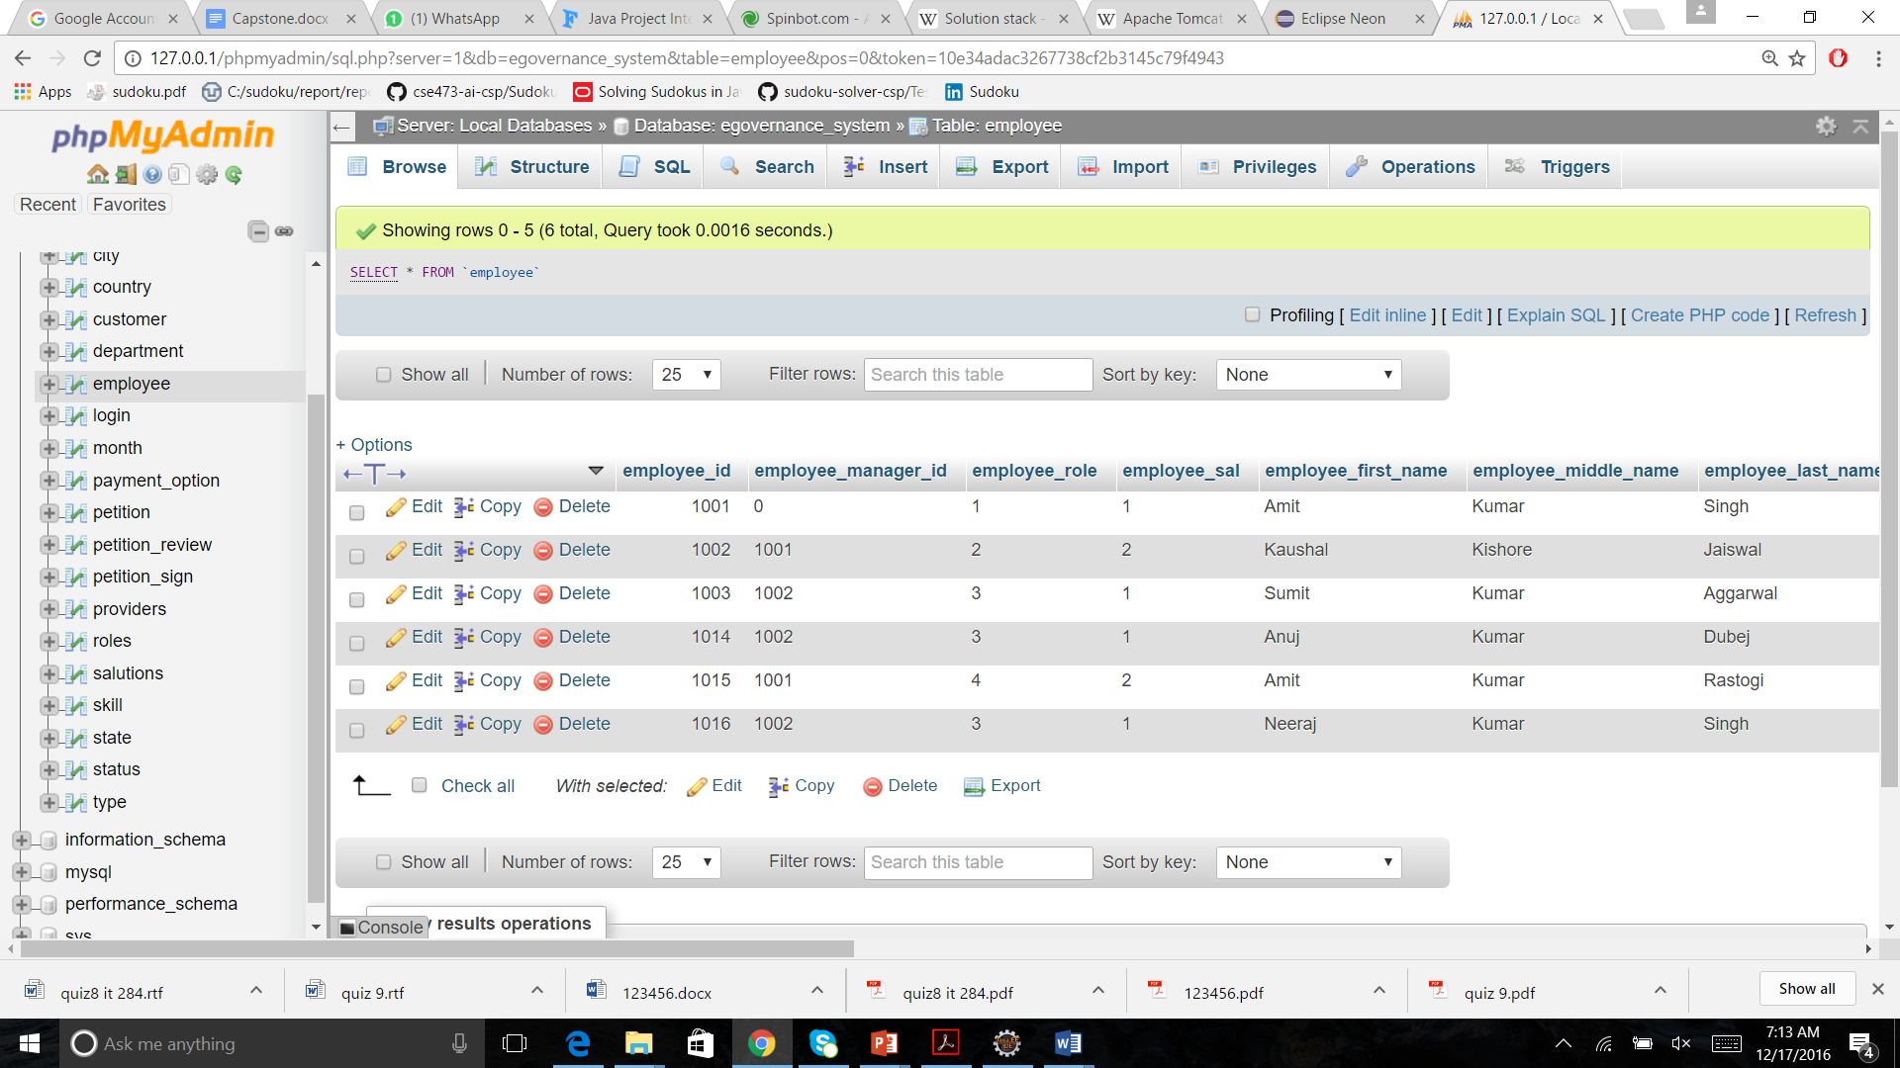

**10. Final integration:**

**10.1. Introduction page :**

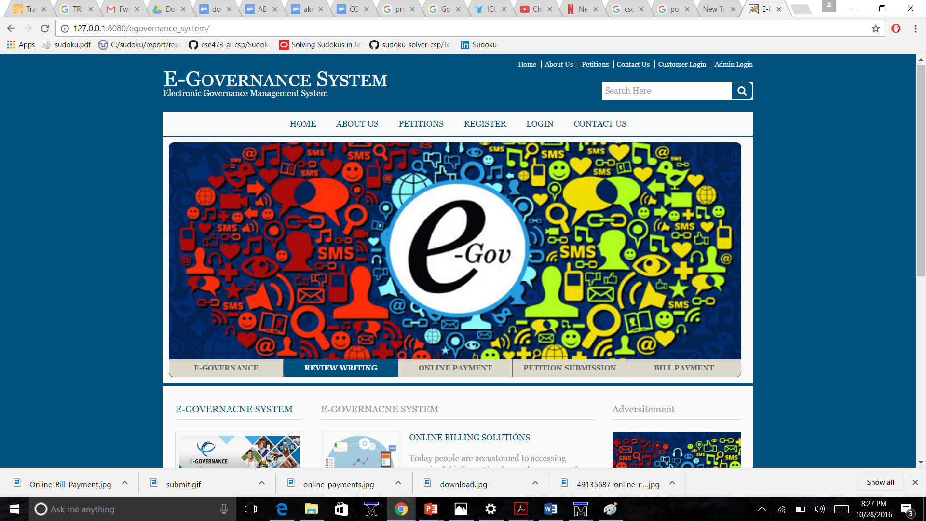

**10.2. Client Page View:**

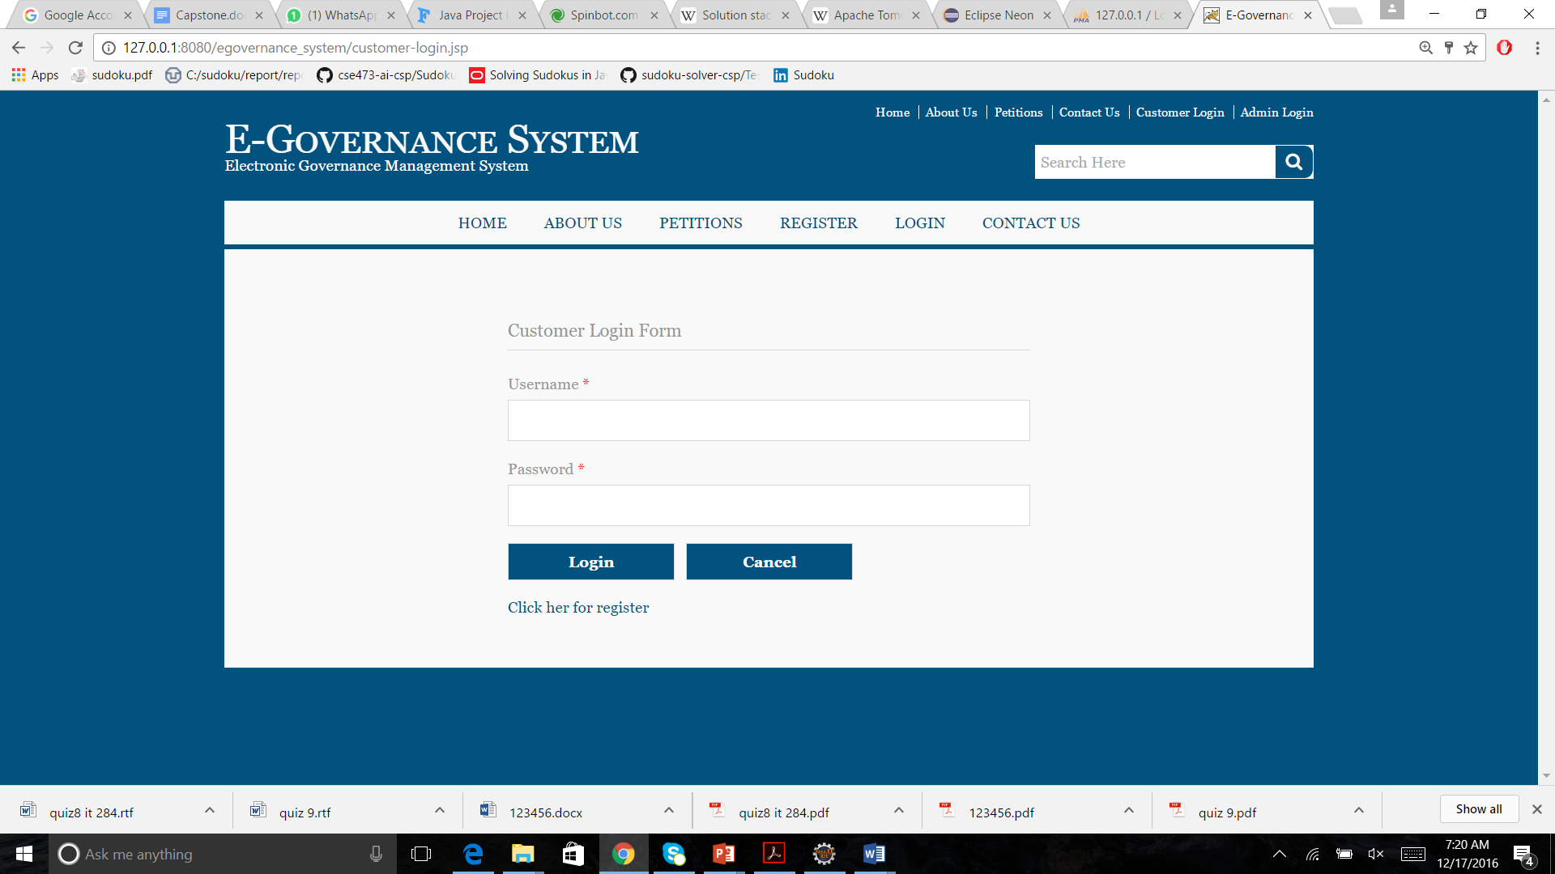

**10.3. Admin Page View:**

